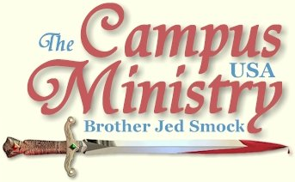
brojed.org
brojed@aol.com
Cell 573-999-0347
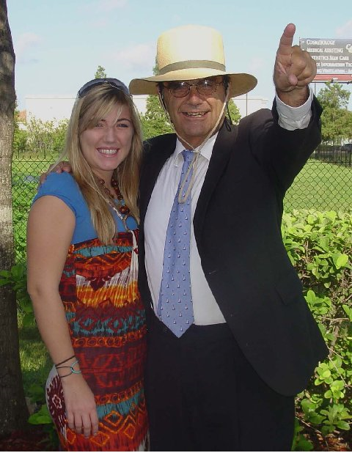
The Day They Left For Ghana
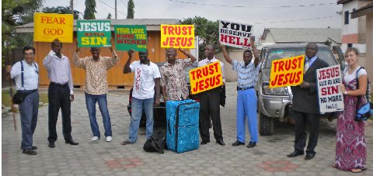
Preparing To Minister in The Market
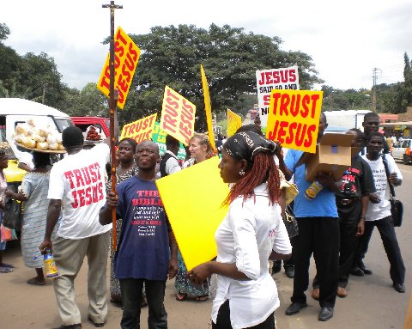
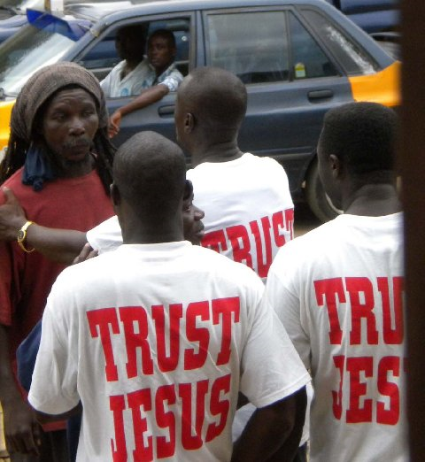

The Baptism of Boldness
August 12, 2009, in the morning seminar, I gave a 2 hour version of my “Who Will Rise Up?” message. I explained how “wisdom crieth without (Prov 1:20).” Notice wisdom cries without, not within the four walls of a church building. If he that wins souls is truly wise, he will go without the established structures and compel men to come into the house of God. Today, I spoke through a translator (Peter) to the students of the seminar; because they were having difficulty with my accent. I sensed a mighty anointing of the Holy Spirit. I concluded by leading the students in prayer that the Lord would give them a baptism of boldness to speak God’s word (Act 4). And indeed he did.
Brother Francis, who is forty years old, said, that Ghana had never experienced what it had yesterday with men and women going into the streets and boldly and loudly declaring the Word of God and calling the multitudes to repentance and faith.
We presented certificates to 73 students for their completion of our School of Evangelism.
As we drove through Accra to a different market this afternoon for the workshop phase of our school, my students, riding a pickup truck in front of us, held high the gospel signs and preached. Ghana is an ideal place for street preaching for life is outdoors here. People are to be seen everywhere. Relatively few have cars, multitudes are walking the streets. Although few have cars, still cars are everywhere. Most of these vehicles could probably not pass inspection in the U.S.
I gave the opening sermon in the street meeting today using a truth horn. Brother Francis did not speak long since he had strained his voice yesterday. Neither Brother Francis nor I got the horn back as we marched through the seemingly endless streets filled with vendors. This was fine with me. I wanted the students to dominate the preaching. Several of them proved to be preaching machines. We were a sight as about 20 of us were winding through the throngs of humanity.
By the time I returned to my room at 4:30, I was exhausted. It is not unusual for me to preach all afternoon and conclude with preaching a church meeting at night. But in Ghana they have me on a schedule of teaching all morning and preaching in the streets in the afternoon and in churches at night. This evening I spoke at New Vision Prophetic Ministry International. The Pastor of this church is the one who has been driving five to six of us around in his Mercedes. His parsonage was right next door to his church which is called New Vision Prophetic Ministry International. Despite the worship service being very lively, I had difficulty staying awake, my head nodded more than once. However, as soon as I took the pulpit I was instantly revived. I preached mightily from 1 John on the subject how we know that we have eternal life. The answer clearly from John is that we keep his commandments. NVPMI is a church primarily made up of youth which was in contrast with the congregation of last night. The youth were very receptive as once again Pastor Peter acted as my translator. I like speaking through a Holy Ghost filled translator like Peter. I seem to be able to feed on his spirit and I am preaching stronger than usual. About half of the congregation came forward to acknowledge sin and commit to turning from all sin and to live a life of obedience which is not difficult when we truly love God (1 John 5:3). It is difficult to sin when one loves God. If one fines it easy to sin, I fear he has left his first love or maybe never really truly has known our loving God.
At the end of the service the church provided Charlotte and me with wrapped gifts. However, Charlotte had stayed back at the guest house tonight since she was very tired. We used to call Charlotte the 1 John Wiz, because she memorized the book and could defend holiness very well with the students.
After church the pastors all sat down to dinner in the parsonage and we were served by the pastor’s wife a good dinner of fried fish and rice. I especially enjoyed the Fanta Orange soda since it was served good and cold, usually the drinks are only slightly chilled.
At 10 PM I returned to my room and Charlotte and I unwrapped our gifts of sandals and looked at the photos which she had downloaded on my computer. I retired at 11 PM.
Who Shall Declare His Generation?
August 13, 2009, Charlotte and I came over here with four large suitcases and each of us having a carry on. Much in our suitcases we brought to distribute among the people. I brought copies of WWRU? and Walking in the Spirit and message t-shirts to give to the pastors and others who helped with my ministry. We also brought the hand held signs. In addition Charlotte brought games, toys, coloring books, stickers and candy to give to children. This morning at the Graceland Fast Food restaurant Charlotte gave much of these materials to Brother Francis’ three children who would be sharing them among their friends. About noon Charlotte was scheduled at the Agape Children’s Home. Charlotte’s field in nursing is pediatrics so we scheduled this meeting so that she might be a blessing to these orphans and that she might have some experience working with and understanding the needs of African children who are raised without fathers or mothers. Pure religion includes visiting fatherless in their affliction (James 2:27).”

One of the elementary teachers introduced Charlotte to 8-10 five and six year old children. She read, played, colored, gave them gifts and worked with them for over an hour. Although they were polite and originally shy around Charlotte, the children soon warmed up to her. Their teacher lamented that Charlotte could not stay with the children longer. I concluded the time in prayer with the children.
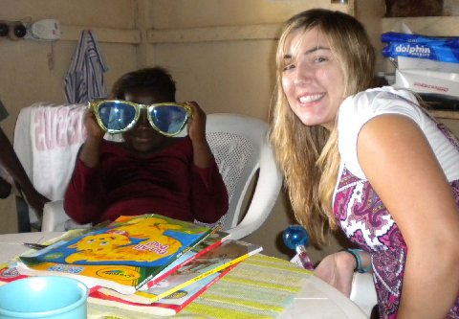
Bro Francis' Daughter

We had to drive about an hour to Nsawam for our next seminar. It may not be that far from Accra; but the road may have been one of the worse that I have been on. It was a rough ride; Francis said they were working on the road. Along the way we stopped at the Bible League which is an organization founded in 1938 “to provide Scriptures and Training worldwide, so that people prepared by the Holy Spirit will be brought into the fellowship of Christ and His Church,” according to their mission statement. The national director, Pius Kwame Agyekum, greeted us warmly in his office with his staff. He said he had heard of me at a conference on evangelism at the University of Kumasi when he was a student. I was impressed that I had a reputation at a university in Ghana having never been in the country. After some small talk, suddenly, the Spirit of the Lord came upon me and I expounded on confrontational evangelism reminding them that “wisdom cries without,” and that to win souls we must be wise and go out where the sinners are in the streets. I spoke of the terror of the Lord. The director called for his Bible to check my Biblical references and affirmed my exhortation by acknowledging that his organization believed in evangelism. Director Pius put his money where his mouth is by providing for our accommodations at the Hans Lodge, which is a pleasant walled compound with several buildings. Charlotte and I have each had our own room in both hotels with plenty of natural light and ventilation. I supposed that we would have had to double up; but Brother Francis is going out of his way to see that we are comfortable.
In the evening I spoke at an Assembly of God church in Nsawam, which is also hosting the seminar. The building was the largest which we have been in so far; but the congregation was the smallest with less than 50 people. The Salvation Army band performed shortly before I was called upon to preach. The band consisted of drums, trombones, cornets, and trumpets. I liked them because they could make a lot of noise without amplification. I do not care for amplified sound, especially when the sound is turned up far louder than needed, which is usually the way it is. I gripped Brother Francis by the arm and said, “We need to take them to the streets with us.” I had been concerned because Francis had informed me yesterday that in this city we would not go into the streets but on Saturday night there would be an open air crusade from a platform. Francis mentioned that he was concerned about making me too tired. Francis smiled broadly and when he took the pulpit to introduce me he also sensed that we should take the band into the streets tomorrow. I must acknowledge that I am a bit spent. It has been my manner for decades to preach all afternoon and sometimes in a church in the evening. But since my arrival in Ghana I have been teaching for over two hours in the morning, preaching in the streets in the afternoon and preaching again within the church at night. My voice is getting a little weak and broken, which is a problem that I rarely have. In all my years I have never lost my voice and I do not anticipate that happening. Brother Francis’ voice I notice is also getting somewhat hoarse. So what is new? Jesus said, “Zeal for my father’s house has eaten me up.”
I preached on the Atonement of Christ taking my text from Romans 5:6-11. I answered my own question which I raised with the congregation, “Why was the death of Christ necessary for our salvation?” The last thirty minutes of the 90 minute sermon I tied in with the theme of our crusade, “Rekindling the Spirit of Evangelism in Ghana.” I asked the same question as the prophet, “Who shall declare his generation (Isa 53:8)?” The church is his generation, we are his offspring. Will we declare his sufferings, his bruising, his rejection, his sorrow, his affliction, his wounding, his oppression, his slaughtering, his imprisonment and judgment for our sins? Will we reveal his sufferings through our lives? Will we declare his resurrection from the dead? Will we manifest the power of the risen Christ?
I concluded by quoting Hebrews 13:12-13: “Wherefore Jesus also, that he might sanctify the people with his own blood, suffered without the gate. Let us go forth therefore unto him without the camp, bearing his reproach.” I asked, “Will we to go forth unto him without the camp, outside the church buildings, bearing his reproach even as he had to go outside the gates of Jerusalem to be humiliated and put to shame by the people and by the gentiles? We love our camp meetings. We are known for our camp meetings; but a camp meeting ought to prepare us to go outside the camp. The church has been content with warming itself around the campfire, while souls are marching madly towards Hell.”
I did not give an altar call. I told the people if they received my message they would be in my seminar in the morning to learn the skills and gain the tools to fulfill God’s commission to go outside the gates of God and to storm the gates of Hell. I was drenched in sweat as I have been after every teaching and sermon I have delivered in Ghana. Even though, it is not really that hot this time of year, low eighties, there is a high humidity. But as Charlotte pointed out it is not as hot as Florida this time of year. Anyway, I am hot for the Lord. I care not to be spewed out of his mouth on judgment day as I fear many church bench warmers will be. But it won’t be my fault because for years in the churches I have been exhorting Christians to rise and stand to their feet and declare our Lord’s generation.
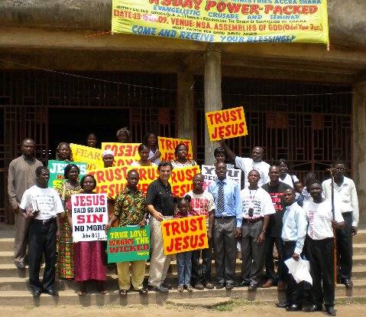
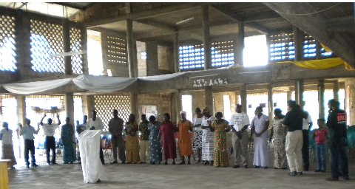
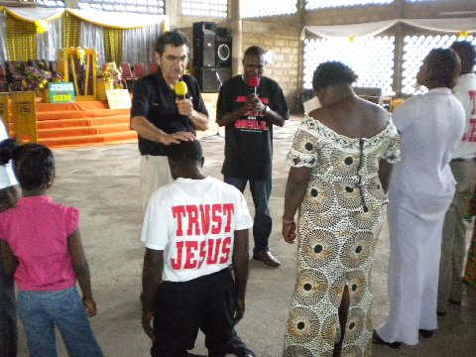
Prayer and Preparation

Invading the Office of the Commission on Human Rights
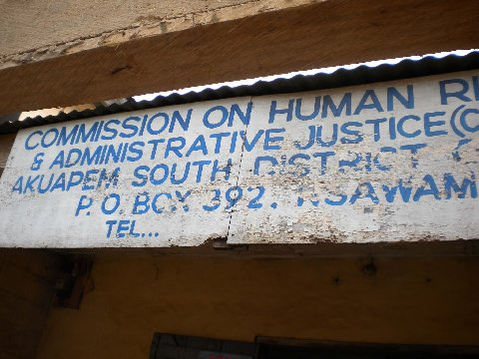
August 14, 2009, the seminar each morning is scheduled to start at 9 AM. We did not get started until 10:15. I started teaching at 10:45 after the music and introductions. I declared that I had come to Ghana to rekindle the spirit of evangelism in Ghana. I explained that Jesus came into the world to rekindle the spirit of evangelism in Israel. His method was to make disciples. I explained that the purpose of the seminar was to make disciples. If we want to know how to evangelize, then we should study how Jesus called and directed his disciples. I spoke of the call of Peter, Andrew, James, John and Matthew to be fishers of men. I then expounded on the call and commission of the 12 from Matthew 10. Jesus gave them power, told them where to go (to the lost sheep), what to do (preach, heal the sick, etc.), where to stay, warned them of dangers, told them how to prepare, predicted the likely reaction (hatred and division), and explained the necessity of bearing one’s cross.
Someone asked where I was in the outlines that I made available. I explained that I have changed direction. I am not following my prepared outlines. Besides, Jesus outlined it best in the 10th chapter of Matthew. With all of our modern methods, we have not improved upon his directions to evangelize Israel and the world.
After the seminar Brother Francis informed me that the Chief would not allow the Salvation Army Band or amplification this week since there was some festival going on. But we were free to sing and preach without amplification. About 20 of us left the front of the church to march through the streets carrying Webber’s provocative signs as well as several TRUST JESUS signs. The multitudes that lined the streets had never seen evangelism after this matter. Many had a look of amazement on their faces. We finally stopped and I gave a fifteen minute message calling for repentance towards God and faith towards our Lord Jesus. Someone was always either preaching or else all were singing in the native tongue. We were quite a sight. Peter a young pastor evangelist was very zealous he even went right into the office of the Commission on Human Rights who had “no child labor” signs and other signs promoting women’s rights and other liberal causes. But these people seemed to love the preaching. Several men asked me to pray for them. In a park I led a group of about 10 youth in a prayer of repentance and faith as they held their hands over their hearts. In the same park I prayed a similar prayer with a group of ladies.
Nsawam is a smaller city than Accra and the numbers were not as large as the market in Accra; but still there were masses of people everywhere. The city streets of Ghana remind me of one endless flee market. Except for the fresh produce I saw nothing of the multitudes of goods that I would be interested in purchasing. The goods available seemed comparable to what one might find at the Dollar Store. Thousands heard the word as we must have marched a few miles through the streets. I think everyone had a wonderful time. Serving Christ is an adventure when you follow as Jesus instructed. What if Matthew had chosen not to respond to Jesus’ call to leave his soft government job and the security of civil service that day? We would not have the book of Matthew to study today.
Over dinner I asked the pastors,“Do you foresee Africa coming out of its extreme poverty and underdevelopment in the near future?” They indicated that they had hope. They thought Africa’s main problem was the corruption of the leaders, who treated the people no better than the British had. Earlier Brother Francis told me that he thought that the European colonial powers were pressured to leave to soon, before Africa was ready for independence. Had they stayed longer they would have developed a much better infrastructure the lack of which is such a hindrance to the development of commerce. The pastors said that there is much oil in Ghana and that the nation is a leading exporter of cocoa.
At night in the A/G church I preached my “Who Will Rise Up?” message. I explained that if we are going to rise up and confront sin we need to make sure that we have confronted and destroyed sin in our own lives. One lady responded to my altar call and confessed to fornication. The A/G pastor was impressed with my message and my leading of his people into the streets.
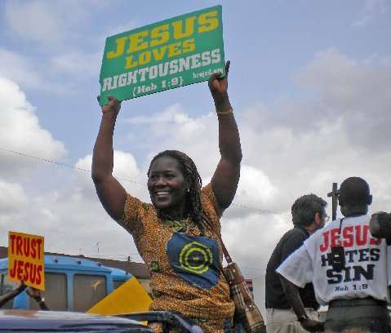
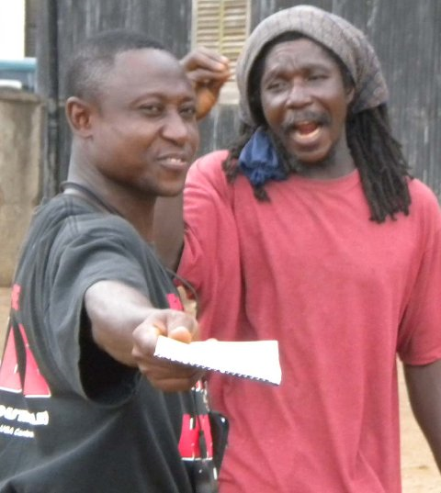
Demon Processed Man
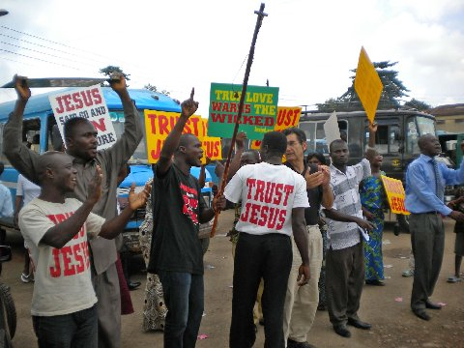
The Market
